Exercise: Function Context
Problems for in-class lab for the “JavaScript Advanced” course @ SoftUni.
Submit your solutions in the SoftUni judge system at https://judge.softuni.bg/Contests/1855/Exercise-Function-Context.

Company
class Company {
// TODO: implement this class...
}

Your Task

Write a Company Class, Which Supports the Described Functionality Below.

Functionality
Constructor()
Should have these 1 property:
- departments - empty array
AddEmployee({username}, {Salary}, {Position}, {Department})
This function should add a new employee to the department with the given name.
- If one of the passed parameters is empty string (""), undefined or null, this function should throw an error with the following message:
"Invalid input!"
- If salary is less than 0, this function should throw an error with the following message:
" Invalid input!"
- If the new employee is hired successfully, you should add him into the departments array and return the following message:

" New employee is hired. Name: {name}. Position: {position}"
bestDepartment()
This function should print the department with the highest average salary and its employees sorted by their salary by descending and by name in the following format:
"Best department is: {best department's name}
Average salary: {best department's average salary}
{employee1} {salary} {position}
{employee2} {salary} {position}
{employee3} {salary} {position}
. . ."

Submission
Submit only your Company class.

Examples
This is an example how the code is intended to be used:
Sample code usage
let c = new Company();
c.addEmployee("Stanimir", 2000, "engineer", "Construction");
c.addEmployee("Pesho", 1500, "electrical engineer", "Construction");
c.addEmployee("Slavi", 500, "dyer", "Construction");
c.addEmployee("Stan", 2000, "architect", "Construction");
c.addEmployee("Stanimir", 1200, "digital marketing manager", "Marketing");
c.addEmployee("Pesho", 1000, "graphical designer", "Marketing");
c.addEmployee("Gosho", 1350, "HR", "Human resources");
console.log(c.bestDepartment());
Corresponding output
Best Department is: Construction
Average salary: 1500.00
Stan 2000 architect
Stanimir 2000 engineer
Pesho 1500 electrical engineer
Slavi 500 dyer

Fibonacci
Write a JS function that when called, returns the next Fibonacci number, starting at 0, 1. Use a closure to keep the current number.

Input
There will be no input.

Output
The output must be a Fibonacci number and must be returned from the function.

Examples
Sample exectuion
let fib = getFibonator();
console.log(fib()); // 1
console.log(fib()); // 1
console.log(fib()); // 2
console.log(fib()); // 3
console.log(fib()); // 5
console.log(fib()); // 8
console.log(fib()); // 13

HEX
class Hex {
// TODO: implement this class...
}

Your Task

Write a Hex Class, Which Supports the Described Functionality Below.

Functionality
Constructor({value})
Should have these 1 property:
- value - number

ValueOf()

This Function Should Return the Value Property of the Hex Class.
ToString()
This function will show its hexidecimal value starting with "0x"
Plus({number})
This function should add a number or Hex object and return a new Hex object.
Minus({number})
This function should subtract a number or Hex object and return a new Hex object.
Parse({string})
Create a parse class method that can parse Hexidecimal numbers and convert them to standard decimal numbers.

Submission
Submit only your Hex class.

Examples
This is an example how the code is intended to be used:
Sample exectuion
let FF = new Hex(255);
console.log(FF.toString());
FF.valueOf() + 1 == 256;
let a = new Hex(10);
let b = new Hex(5);
console.log(a.plus(b).toString());
console.log(a.plus(b).toString()==='0xF');
0xFF
0xF
true

Table

Use the Given Skeleton to Solve This Problem.
Note: You Have NO Permission to Change Directly the Given HTML (Index.html File).
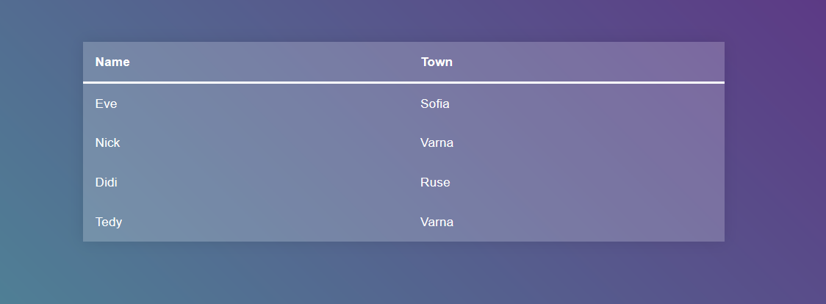

Your Task
Write the missing JavaScript code to make the Table application work as expected.
When you click on an item from the table you should change its background color to "#413f5e".

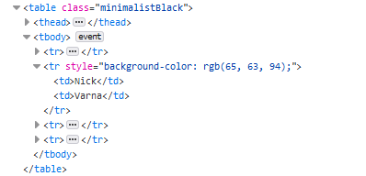
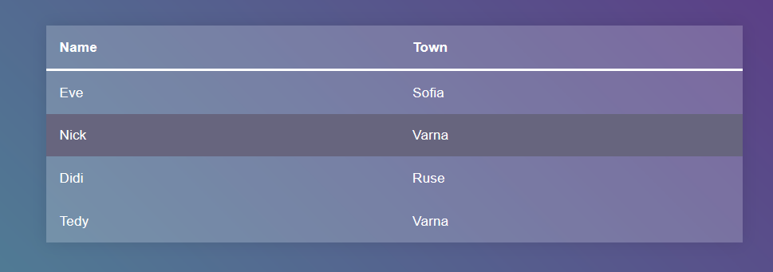
If the item you've clicked already has a style property you should remove it.
If one of the elements is clicked and you click another the first element's style property should be removed and you should change the background color of the newly clicked item.
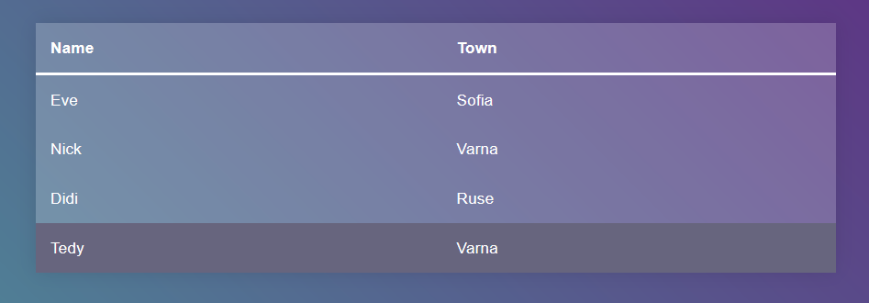
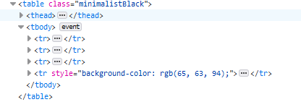
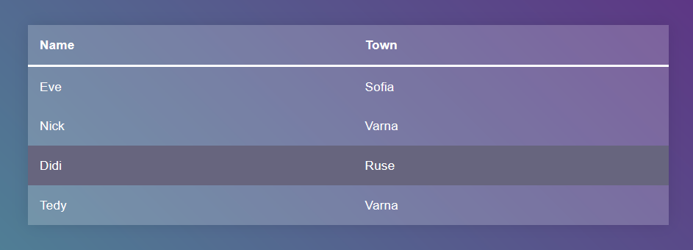
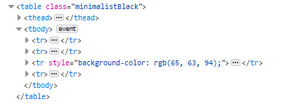
Note: You shouldn't change the head of the table, even if it is clicked.

Next Article
Write a JS program that sequentially displays articles on a web page when the user clicks a button. You will receive an array of strings that will initialize the program. You need to return a function that keeps the initial array in its closure and every time it’s called, it takes the first element from the array and displays it on the web page, inside a div with ID "content". If there are no more elements left, your function should do nothing.

HTML and JavaScript Code
You are given the following HTML code:
article.html
<!DOCTYPE html>
<html lang="en">
<head>
<meta charset="UTF-8">
<title>Next Article</title>
<style>div{width:600px; text-align: center; font-size: 1.5em} article{border: 2px solid blue; padding: 2em; margin: 1em}</style>
<script src="https://code.jquery.com/jquery-3.1.1.min.js" integrity="sha256-hVVnYaiADRTO2PzUGmuLJr8BLUSjGIZsDYGmIJLv2b8=" crossorigin="anonymous"></script>
<script src="next-article.js"></script>
</head>
<body>
<div id="content"></div>
<div><button onclick="showNext()">Show Next Article</button></div>
<script>
let articles =[
"Cats are the most popular pet in the United States: There are 88 million pet cats and 74 million dogs.",
"A group of cats is called a clowder.",
"Cats have over 20 muscles that control their ears.",
"A cat has been mayor of Talkeetna, Alaska, for 15 years. His name is Stubbs.",
"The world's largest cat measured 48.5 inches long."
];
let showNext = getArticleGenerator(articles);
</script>
</body>
</html>
It comes together with the following JavaScript code:
next-article.js
function getArticleGenerator(articles) {
// TODO
}
Your function will be called automatically, there is no need to attach any event listeners.

Input
You will receive and array of strings.

Output
Return a function that displays the array elements on the web page.

Examples
